**DEPARTMENT Of INFORMATION TECHNOLOGY**

**Government college of engineering, Amravati**



MINI PROJECT

IN

PYTHON

‘‘ COMPANY WORK MANAGEMENT ’’

Prepared by: - Guided by:-

Mast. DEVESH DHOTE (19007055) **Prof. A.W.BHADE**

Mast. RITIK SINGH (19007061) ( H.O.D. )

Miss. RADHIKA TIKAR (19007065)

Certificate

This to certify that this project work is submitted by DEVESH DHOTE, RITIK SINGH, RADHIKA TIKAR having ID’s 19007055, 19007061, 19007065 respectively of semester III of B.Tech in Information Technology was carried out by them under the guidance & supervision of Prof. A.W.BHADE during academic year 2020-21 for the

Course Title:-Data Structure and Algorithm Lab Course Code:-ITU324

Date: 26/12/2020

Head of Dept. Faculty

(Prof.A.W.Bhade) (Prof.A.W.Bhade)

ACKNOWLEDGEMENT

I wish to express my deep gratitude and sincere thanks to H.O.D, A.W.BHADE, Department Of Information Technology for his encouragement and for all the facilities that he provided for this project work .I sincerely appreciate this magnanimity by taking me into his fold for which I shall remain indebted to him .

I extend my hearty thanks to Prof. A.W.BHADE, Faculty data structure and algorithm (ITU-324), who guided me to the successful completion of this project I take this opportunity to express my deep sense of gratitude for his invaluable guidance ,constant encouragement ,constructive comments ,sympathetic attitude and immense motivation ,which has sustained my efforts at all stages of this project work.

I can’t forget to offer my sincere thanks to my classmates who help me to carry out this project work successfully & for their valuable advice & support, which I receive from them time to time.

**INTRODUCTION**

TK-INTER : Tkinter is the most commonly used library for developing GUI (Graphical User Interface) in Python. It is a standard Python interface to the Tk GUI toolkit shipped with Python. As Tk and Tkinter are available on most of the Unix platforms as well as on the Windows system, developing GUI applications with Tkinter becomes the fastest and easiest.

Widgets in Tkinter are the elements of GUI application which provides various controls (such as Labels, Buttons, ComboBoxes, CheckBoxes, MenuBars, RadioButtons and many more) to users to interact with the application.

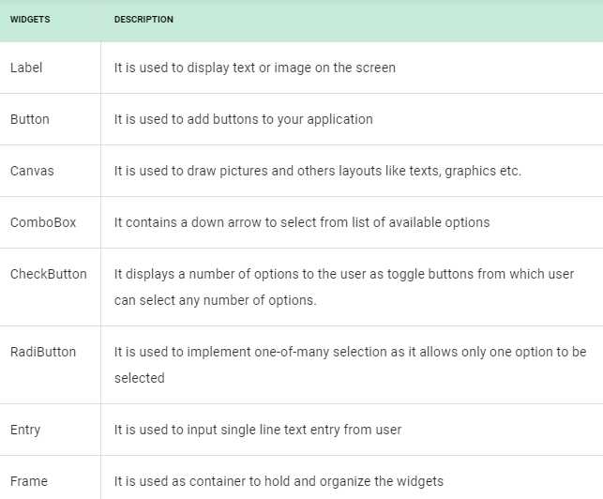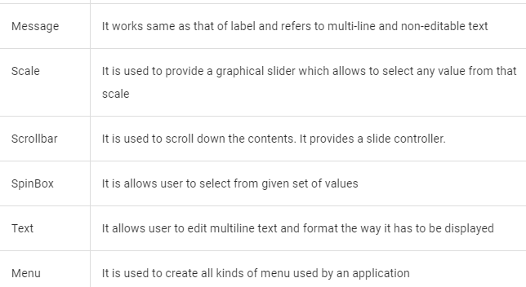

**Geometry Management**

Creating a new widget doesn’t mean that it will appear on the screen. To display it, we need to call a special method: either **grid**, **pack**(example above), or **place**.

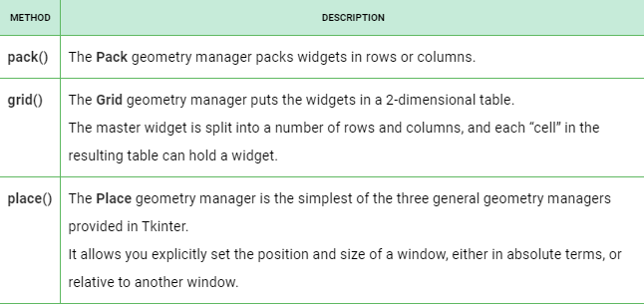

File handling in PYTHON: Python too supports file handling and allows users to handle files i.e., to read and write files, along with many other file handling options, to operate on files. The concept of file handling has stretched over various other languages, but the implementation is either complicated or lengthy, but alike other concepts of Python, this concept here is also easy and short. Python treats file differently as text or binary and this is important. Each line of code includes a sequence of characters and they form text file. Each line of a file is terminated with a special character, called the EOL or End of Line characters like comma {,} or newline character. It ends the current line and tells the interpreter a new one has begun. Let’s start with Reading and Writing files.

We use open () function in Python to open a file in read or write mode. As explained above, open ( ) will return a file object. To return a file object we use open() function along with two arguments, that accepts file name and the mode, whether to read or write. So, the syntax being: open(filename, mode). There are three kinds of mode, that Python provides and how files can be opened:

* “ r “, for reading.
* “ w “, for writing.
* “ a “, for appending.
* “ r+ “, for both reading and writing

One must keep in mind that the mode argument is not mandatory. If not passed, then Python will assume it to be “ r ” by default.

# Python code to illustrate read() mode

file = open("file.text", "r")

print (file.read())

# Python code to illustrate read() mode character wise

file = open("file.txt", "r")

print (file.read(5))

# Python code to create a file

file = open('geek.txt','w')

file.write("This is the write command")

file.write("It allows us to write in a particular file")

file.close()

# Python code to illustrate append() mode

file = open('geek.txt','a')

file.write("This will add this line")

file.close()

**Source Code :**

from tkinter import *  
from tkinter import messagebox  
import os  
import random  
import smtplib  
from main import * #remove this line if you provide your mail_pass in this code  
#main navachya file madhe sender cha password save aahe  
import requests  
Admin_mail ='deveshdhote111@gmail.com' #edit your gmail id here  
# Emailpassword = 'Provide your mail password here'  
#worker id start from ZERO  
f= open("total_worker.txt",'r')  
data = f.readlines()  
W_ID=int(data[0])+1  
f.close()  
  
def get_valid_Email(email_id):  
 list_of_survice_provider_name = ["gmail", "yahoo", "outlook", "hotmail"]  
 if '@' in email_id and ".co" in email_id:  
 index_of_AT = email_id.find("@")  
 index_of_dot = email_id.find(".")  
 provider_name = email_id[index_of_AT + 1:index_of_dot]  
 if provider_name in list_of_survice_provider_name:  
 return False  
 else:  
 messagebox.showwarning("Invalid provider ", "we only provide service for gmail / yahoo / outlook / hotmail ")  
 return True  
 else:  
 messagebox.showwarning("WRONG EMAIL ID", "email id must have @__survice_provider_name__.co in it ")  
 return True

def get_valid_mob(mob_no):  
 if mob_no<=1000000000 or mob_no>=9999999999:  
 messagebox.showwarning(" WRONG MOBILE NUMBER ", "MOBILE NUMBER SHOULD HAVE 10 DIGITS")  
 return True  
 else:  
 return False  
  
def update(num):  
 new = i.get()+'\n'  
 cscreen.destroy()  
 f = open(wid.get()+'.txt','r')  
 data=f.readlines()  
 if num==1:  
 data[0]=new  
 elif num==2:  
 data[1] = new  
 elif num==3:  
 data[2] = new  
 elif num==4:  
 if get_valid_mob( int(i.get()) ):  
 return  
 else:  
 data[3] = new  
 elif num==5:  
 if get_valid_Email(i.get()):  
 return  
 else:  
 data[4] = new  
 elif num==6:  
 data[5] = new  
 f2 = open(wid.get() + ".txt", 'w')  
 new = "".join(data)  
 f2.write(new)  
 f2.close()  
 messagebox.showinfo("UPDATED"," DATA ADDED SUCCESSFULLY ")  
 f.close()

def change(num): #new screen,ek entry madhun string input ghil,return entry.get() , check(line number)  
 global cscreen, i  
 cscreen = Toplevel()  
 cscreen.geometry(f"200x200+{width//2+100}+100")  
 cscreen.title(" UPDATE INFO ")  
 label = Label(cscreen, text="ENTER NEW DATA").pack()  
 i = Entry(cscreen, bd=6)  
 i.pack()  
 Button(cscreen, text=" SUBMIT ", bg="black", fg="white", relief=SUNKEN, bd=7, command=lambda:update(num)).pack(pady=20)  
  
def send_sms(otp):  
 f = open(wid.get() +'.txt','r')  
 data = f.readlines()  
 mob_num = data[3]  
 url = "https://www.fast2sms.com/dev/bulk"  
 payload = f"sender_id=FSTSMS&language=english&route=qt&numbers={mob_num}&message=42194&variables=" + '{' + "#BB#"+'}'+f"&variables_values={otp}"  
 headers = {  
 'authorization': "0coJXH1ReiwrFtYyqxSANhKV57CEkgL4dzTuZpM26GlPaQ3vnjHQL6ZGrNTKW8amqEgObt2V1v5iXAYd",  
 'cache-control': "no-cache",  
 'content-type': "application/x-www-form-urlencoded"  
 }  
 response = requests.request("POST", url, data=payload, headers=headers)  
 print(response.text)  
 f.close()

def send_mail(otp):  
 Subject = "PASSWORD CHANGE OTP"  
 Message = f"YOUR OTP IS \n\n {otp}"  
 wid=w_id.get()  
  
 f = open(wid+'.txt','r')  
 data = f.readlines()  
 res_mail = data[4] # RECEIVER EMAIL ID TAKA LAGAL  
 server = smtplib.SMTP_SSL("smtp.gmail.com", 465)  
 server.login(Admin_mail, Emailpassword)  
 server.sendmail(Admin_mail, res_mail,("Subject: " + str(Subject) + "\n\n" + str(Message)))  
 server.quit()  
 f.close()  
  
def otp_check():  
 a = int(i22.get())  
 if otp == a:  
 change(5)  
 else:  
 messagebox.showwarning("OTP","WRONG OTP")

def otp_get():  
 global scr,i22  
 scr = Toplevel()  
 scr.geometry(f"250x100+{width//2+100}+100")  
 scr.title(" otp ")

Label(scr, text="ENTER YOUR OTP:").pack()  
 i22 = Entry(scr, bd=6,width=20)  
 i22.pack()

Button(scr, text=" LOGIN ", bg="black", fg="white", relief=SUNKEN, bd=7,command=otp_check).pack()

def mail(otp):  
 if int( wid.get() )<0 or int( wid.get() )>=W_ID:  
 messagebox.showwarning("warning", "wrong id ")  
 return  
 abc=messagebox.showinfo(" OTP SENT ", "OTP SENT TO YOUR EMAIL PLZ CONFORM OTP ")

send_mail(otp)  
 if abc=="ok":  
 fscreen.destroy()  
 otp_get()

def mob(otp):  
 if int( wid.get() )<0 or int( wid.get() )>=W_ID:  
 messagebox.showwarning("warning", "wrong id ")  
 return  
 abc = messagebox.showinfo(" OTP SENT ", "OTP SENT TO YOUR mobile number PLZ CONFORM OTP ")  
 send_sms(otp)  
 if abc == "ok":  
 fscreen.destroy()  
 otp_get()

def forgot_pass():# worker forgot password  
 global fscreen , wid  
 fscreen = Toplevel()  
 fscreen.geometry(f"400x400+{width//2+100}+100")  
 fscreen.title(" Change Password ")

Label(fscreen, text="*** ENTER YOUR ID ***", bg="gold", fg="white", font="system 12 bold",padx=20, pady=10, relief=GROOVE).pack(side=TOP, fill=X, pady=20)  
 wid = Entry(fscreen, bd=6)  
 wid.pack()

Label(fscreen, text="*** CHOOSE ONE WAY TO CHANGE PASSWORD ***", bg="gold", fg="white", font="system 12 bold",padx=20, pady=10, relief=GROOVE).pack(side=TOP, fill=X, pady=20)  
 global otp  
 otp = random.randrange(100000, 1000000)

b1 = Button(fscreen, text=" E-MAIL ", bg="black", fg="white", relief=SUNKEN, bd=7,command=lambda: mail(otp)).pack(pady=20)  
 b2 = Button(fscreen, text=" MOBILE_NUMBER ", bg="black", fg="white", relief=SUNKEN, bd=7,command=lambda: mob(otp)).pack(pady=7)  
  
  
def wf():  
 screen5.destroy()

def check_w_info():  
 screen4.destroy()  
 f = open(wid.get() + '.txt', 'r')  
 data = f.readlines()  
 global screen5  
 screen5 = Toplevel()  
 screen5.geometry(f"{width}x{height}+0+0")  
 screen5.title(" YOUR INFORMATION ")

Label(screen5, text=f"First name : {data[0]} ").pack()  
 Label(screen5, text=f"Last name : {data[1]} ").pack()  
 Label(screen5, text=f"Date Of Birth : {data[2]} ").pack()  
 Label(screen5, text=f"Mobile No. : {data[3]} ").pack()  
 Label(screen5, text=f"Email_ID : {data[4]} ").pack()  
 Label(screen5, text=f"Per_day_salary: {data[6]} ").pack()  
 Label(screen5, text=f"\ntotal working days : {data[7]} ").pack()  
 f.close()  
 Button(screen5, text=" QUIT ", bd=10, width="10", height="1", bg="gray50", fg="black", font="comicsan 10 bold",command=quit).pack(side=RIGHT, anchor="sw", pady=50, padx=30)

def edit_w_info():  
 screen4.destroy()  
 f = open(wid.get() + '.txt', 'r')  
 data = f.readlines()  
 global screen5  
 screen5 = Toplevel()  
 screen5.geometry(f"{width//2}x{height}+0+0")  
 screen5.title(" EDIT INFORMATION ")  
  
 Label(screen5,text='').pack()  
 Label(screen5, text=f"First name : {data[0]} ", font="comicsan 10 bold").pack(pady=1)  
 Button(screen5, text=' EDIT ',bd=3, width="5", height="1", bg="gray80", command=lambda:change(1)).pack()  
  
 Label(screen5, text='').pack()  
 Label(screen5, text=f"Last name : {data[1]} ", font="comicsan 10 bold").pack()  
 Button(screen5, text=' EDIT ', bd=3, width="5", height="1", bg="gray80", command=lambda:change(2)).pack()  
  
 Label(screen5, text='').pack()  
 Label(screen5, text=f"Date Of Birth : {data[2]} ", font="comicsan 10 bold").pack()  
 Button(screen5, text=' EDIT ', bd=3, width="5", height="1", bg="gray80", command=lambda:change(3)).pack()  
  
 Label(screen5, text='').pack()  
 Label(screen5, text=f"Mobile No. : {data[3]} ", font="comicsan 10 bold").pack()  
 Button(screen5, text=' EDIT ', bd=3, width="5", height="1", bg="gray80", command=lambda:change(4)).pack()  
  
 Label(screen5, text='').pack()  
 Label(screen5, text=f"Email_ID : {data[4]} ", font="comicsan 10 bold").pack()  
 Button(screen5, text=' EDIT ', bd=3, width="5", height="1", bg="gray80", command=lambda:change(5)).pack()  
  
 Label(screen5, text='').pack()  
 Label(screen5, text="password : * * * * * * * ", font="comicsan 10 bold").pack()  
 Button(screen5, text=' EDIT ', bd=3, width="5", bg="gray80", height="1", command=lambda:change(6)).pack()  
  
 f.close()  
 Button(screen5, text=" QUIT ", bd=10, width="10", height="1", bg="gray50", fg="black", font="comicsan 10 bold",command=wf).pack(side=RIGHT, anchor="sw", pady=50, padx=30)

def checkworkerpassword():  
 if int( wid.get() )<0 or int( wid.get() )>=W_ID:  
 messagebox.showwarning("warning", "wrong id ")  
 else:  
 f = open(wid.get()+'.txt','r')  
 data=f.readlines()  
 if wpass.get()+'\n' == data[5]:  
 global screen4  
 screen4 = Toplevel()  
 screen4.geometry(f"{width//2}x{height}+{width//2}+0")  
 screen4.title(" WORKER's SPACE ")

Button(screen4, text=" CHECK YOUR INFO ", bg="cyan", fg="black", relief=SUNKEN, bd=6,command = check_w_info).pack(pady=20)

Button(screen4, text=" EDIT YOUR INFO ", bg="cyan", fg="black", relief=SUNKEN, bd=6,command = edit_w_info).pack(pady=20)  
 else:  
 messagebox.showwarning("warning", "wrong password ")  
 f.close()

def worker():  
 global wpass, wid  
 Label(root, text=" Enter your ID : ",pady=10,font = "comicsan 10 bold").pack()

wid= Entry(root, bd=6)  
 wid.pack(ipadx=40)  
 Label(root, text=" Enter your password : ",pady=10,font = "comicsan 10 bold").pack()  
 wpass = Entry(root, bd=6)  
 wpass.pack(ipadx=40)  
  
 Button(root,text=" LOGIN ",bg="black",fg="white", relief=SUNKEN,bd=7,command = checkworkerpassword).pack(pady=20)

Button(root, text=" forgot password ", bg="green yellow", fg="black", relief=SUNKEN, bd=5,command = forgot_pass).pack(pady=10)

Button(root, text=" QUIT ", bd=10, width="10", height="1", bg="gray50",fg="black", font="comicsan 10 bold", command=quit ).pack(side=RIGHT, anchor="sw", pady=50, padx=30)  
  
  
def add_attedance_in_respective_file():  
 if int( E2.get() )<0 or int( E2.get() )>=W_ID:  
 messagebox.showwarning("warning", "wrong id ")  
 else:  
 file = open(E2.get()+".txt", "r")  
 data = file.readlines()

if data[5]==E3.get() +'\n':  
 data[7] = str( int(data[7])+1 )  
 f = open(E2.get()+".txt", 'w')  
 new = "".join(data)  
 f.write(new)  
 f.close()

messagebox.showinfo("SUCCESS", "ATTEDANCE ADDED SUCCESSFULLY")  
 screen3.destroy()  
 else:  
 messagebox.showwarning("warning","wrong password ")  
 file.close()

def attedance():  
 global screen3,E2,E3  
 screen3 = Toplevel()  
 screen3.geometry(f"{width}x{height}+0+0")  
 screen3.title(" ATTEDANCE ")  
  
 Label(screen3, text="Enter your ID : ").pack()  
 E2 = Entry(screen3, bd=6)  
 E2.pack()

Label(screen3, text=" TYPE YOUR PASSWORD : ").pack()  
 E3 = Entry(screen3, bd=6)  
 E3.pack()

Button(screen3, text=" LOGIN ", bg="black", fg="white", relief= SUNKEN, bd=7,command = add_attedance_in_respective_file).pack(pady=20)  
 Button(screen3, text=" forgot password ", bg="green yellow", fg="black", relief=SUNKEN, bd=5,command = forgot_pass).pack(pady=10)  
  
  
def final_submit():  
 global W_ID  
 new_file = open(str(W_ID)+".txt", "a")  
 new_file.write("Per_day_salary : " + E3.get() + '\n')  
 new_file.write("0" + '\n')  
 new_file.close()  
 screen2.destroy()  
 W_ID += 1  
 f = open("total_worker.txt", 'w')  
 f.write(str(W_ID))  
 f.close()

def f():  
 global E3  
 if (E2.get() == Admin_pass):  
 Label(screen2, text=f"Enter per day salary of this worker whose id is {W_ID} :").pack()  
 E3 = Entry(screen2, bd=6)  
 E3.pack()  
 Button(screen2, text=" SUBMIT ", bg="black", fg="white", relief=SUNKEN, bd=7, command=final_submit).pack(pady=20)  
 else:  
 messagebox.showinfo(" --ERROR-- ","WRONG ADMIN PASSWORD")

def set_W_ID():  
 global screen2, E2  
 screen2 = Toplevel()  
 screen2.geometry(f"300x300+{width//2+100}+100")  
 screen2.title(" NEW_WORKER ")  
 Label(screen2, text="Enter ADMIN PASSWORD :").pack()  
 E2 = Entry(screen2, bd=6, show='* ')  
 E2.pack()  
 Button(screen2, text=" SUBMIT ", bg="black", fg="white", relief=SUNKEN, bd=7,command=f).pack(pady=20)

def new_w_added():  
 if i1.get() == "" or i2.get() == "" or i3.get() == "" or i4.get() == "" or i5.get() == "" or i6.get() == "" :  
 messagebox.showerror("Error", "All fields are mandatory!")  
 elif get_valid_Email(i5.get()):  
 pass  
 elif get_valid_mob(int(i4.get())):  
 pass  
 else:  
 new_file = open(str(W_ID)+".txt", "w")  
 new_file.write(i1.get() + '\n')  
 new_file.write(i2.get() + '\n')  
 new_file.write(i3.get() + '\n')  
 new_file.write(i4.get() + '\n')  
 new_file.write(i5.get() + '\n')  
 new_file.write(i6.get() + '\n')  
 new_file.close()  
 m=messagebox.showinfo(" W E L C O M E ", f"REGISTRATION SUCCESSFULL with \n\nID : {W_ID} \n\n NOTE YOUR ID & tell manager tu gave you per_day_salary_info")  
 if m == "ok":  
 screen.destroy()  
 set_W_ID()

def addworker():  
 global screen,i1,i2,i3,i4,i5,i6  
 screen = Toplevel()  
 screen.geometry(f"{width//2}x{height}+{width//2}+0")  
 screen.title(" NEW_WORKER ")

Label(screen, text="************* ENTER WORKERS ALL DETAILS *************", bg="red", fg="white",font="comicsan 12 bold", padx=20, pady=10, relief=GROOVE).pack(side=TOP, fill=X)

label1 = Label(screen, text="Enter your first name:").pack()  
 i1 = Entry(screen, bd=6)  
 i1.pack()

label2 = Label(screen, text="Enter your last name:").pack()  
 i2 = Entry(screen, bd=6)  
 i2.pack()

label3 = Label(screen, text="Enter your Date Of Birth: in DD/MM/YYYY Format").pack()  
 i3 = Entry(screen, bd=6)  
 i3.pack()

label4 = Label(screen, text="Enter your Mobile No.:").pack()  
 i4 = Entry(screen, bd=6)  
 i4.pack()

label5 = Label(screen, text="Enter your Email:\nservice provide should be gmail / yahoo / outlook / hotmail").pack()  
 i5 = Entry(screen, bd=6)  
 i5.pack()

label6 = Label(screen, text="SET YOUR PASSWORD:").pack()  
 i6 = Entry(screen, bd=6)  
 i6.pack()

Button(screen, text=" LOGIN ", bg="black", fg="white", relief=SUNKEN, bd=7,command = new_w_added).pack(pady=20)  
  
Admin_pass = "12345"  
def checkadminpassword():  
 if (E1.get() == Admin_pass):  
 Button(root, text=" ADD_NEW_WORKER ", bd=10, width="30", height="1", bg="gold3", fg="white",command=addworker).pack(pady=10)  
 Button(root, text=" START_ATTEDANCE ", bd=10, width="30", height="1", bg="gold3", fg="white",command=attedance).pack(pady=10)  
 Button(root, text=" QUIT ", bd=10, width="10", height="1", bg="gray50", fg="black", font="comicsan 10 bold",command=quit).pack(side=RIGHT, anchor="sw", pady=50, padx=30)  
 else:  
 messagebox.showinfo(" --ERROR-- ","WRONG ADMIN PASSWORD")

def manager():  
 global E1  
 Label(root, text=" Enter admin password : ",pady=10,font = "comicsan 10 bold").pack()

E1 = Entry(root, bd=6,show="* ")  
 E1.pack(ipadx=40)  
 Button(root,text=" LOGIN ",bg="black",

fg="white",relief=SUNKEN,bd=7,command = checkadminpassword).pack(pady=20)  
  
root = Tk()  
global width, height  
w = root.winfo_screenwidth()  
h= root.winfo_screenheight()  
width = int(w)  
height = int(h)  
root.geometry(f"{width//2}x{height}+0+0")  
root.title(" MAIN WINDOW ")  
  
Button(root, text=" MANAGER ", bd=10, width="20", height="2", bg="#532e1c", fg="white", command=manager).pack(pady=15)  
Button(root, text=" WORKER ", bd=10, width="20", height="2", bg="#532e1c", fg="white", command=worker).pack(pady=15)  
  
root.mainloop()

**Output :**

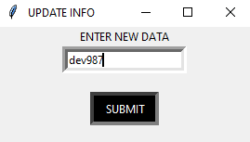 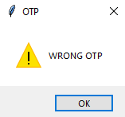

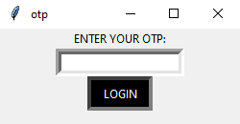 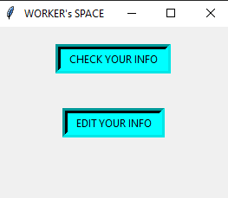

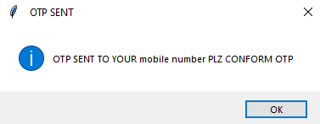 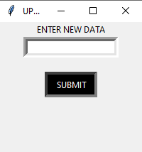 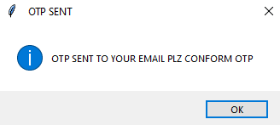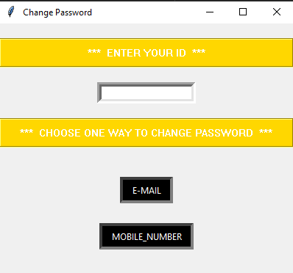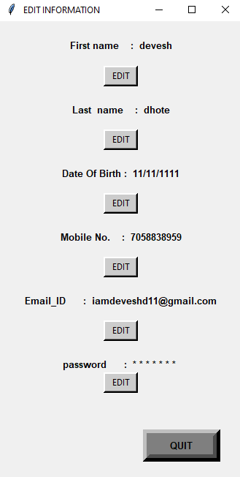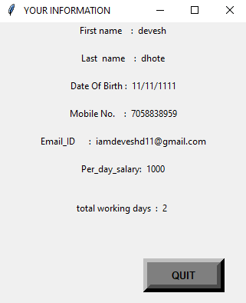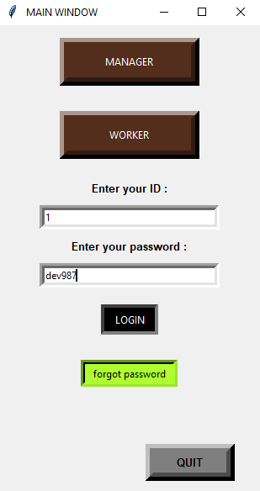 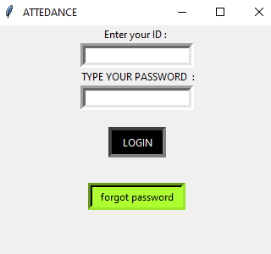 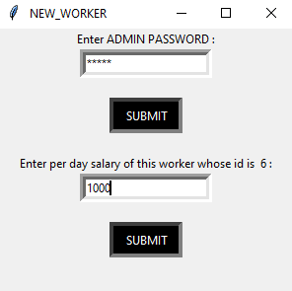 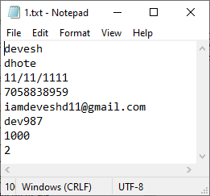 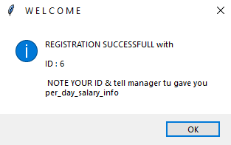 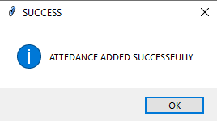

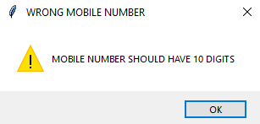 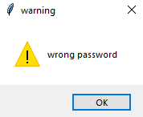

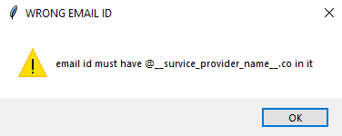 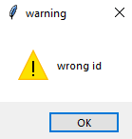 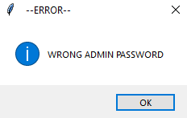 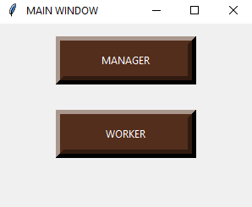 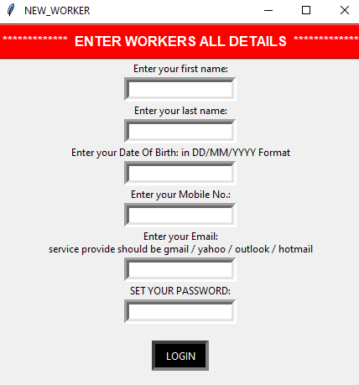 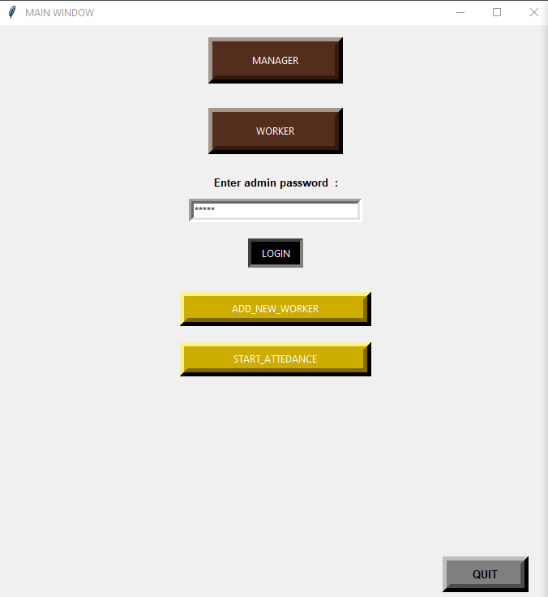

THE END!!!

**Conclusion:-**

We make COMPANY WORK MANAGEMENT SYSTEM successfully with the help of PYTHON language and using TK-inter module and it is very entertaining.